DEALS TO TACOMA

The city of Tacoma sits on the Puget Sound with Mount Rainier in the background. Located 30 miles south of Seattle and 30 miles north of the state capital Olympia, Tacoma is a convenient and scenic destination. Book a trip to Tacoma via Seattle-Tacoma International Airport on Virgin America. Live it up at 35,000 feet with WiFi, on-demand entertainment, and more on every flight.

(MARKET IMAGE HERE)

Find Deals From These Cities

INSERT FARE GRID FROM / TO Version (if available!)



Top Things To Do in Tacoma

With many beautiful parks and world-class museums, Tacoma offers plenty for both locals and visitors to enjoy. If you’ll be visiting and are thinking about what to do in Tacoma, put some of these popular attractions on your list of “Tacoma things to do”.

* Wander through the fascinating Chihuly Bridge of Glass, a 500-foot-long pedestrian overpass that links the Museum of Glass to downtown Tacoma and its cultural corridor. We bet you’ve never seen anything like it!
* Rent a bike or take a leisurely walk along the two-mile Ruston Way Promenade, Tacoma's premier waterfront drive.
* Relax at Kopachuck State Park’s saltwater beach while taking in a sunset or admiring the scenic views of the Olympic Mountains and Puget Sound.

Travel Tips and Resources

[Must-Dos in Tacoma](http://www.traveltacoma.com/things-to-do)

[Tacoma Hotelshttp://www.tripadvisor.com/Hotels-g58775-Tacoma_Washington-Hotels.html](http://www.tripadvisor.com/Hotels-g58775-Tacoma_Washington-Hotels.html)

[Tacoma Restaurantshttp://www.tripadvisor.com/Restaurants-g58775-Tacoma_Washington.html](http://www.tripadvisor.com/Restaurants-g58775-Tacoma_Washington.html)

[Tacoma Shopping Guidehttp://downtowntacoma.com/shop](http://downtowntacoma.com/shop)

[Tacoma Nightlife and Entertainmenthttp://roadtrippers.com/us/tacoma-wa/activities-nightlife-and-party-tacoma-6059?lat=40.80972&lng=-96.67528&z=5](http://roadtrippers.com/us/tacoma-wa/activities-nightlife-and-party-tacoma-6059?lat=40.80972&lng=-96.67528&z=5)

[Tacoma Travel Tips](http://www.fodors.com/world/north-america/usa/washington/washington-cascade-mountains-and-valleys/places/tacoma)

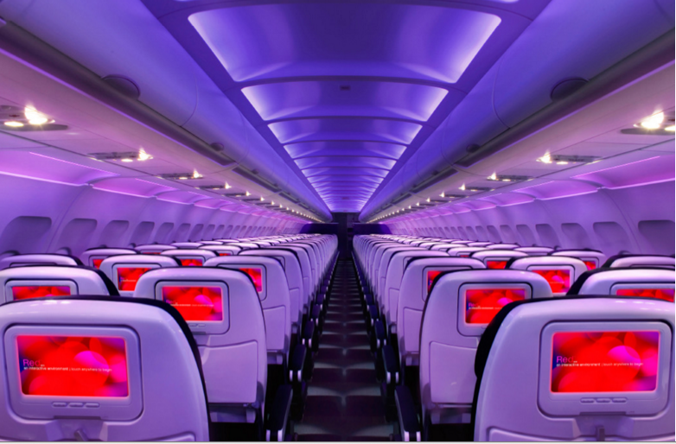

Main Cabin Main Cabin Select First Class

(add links to Cabin Class Pages)

Ready. Set. Fly.

Book your Mood-lit Ride to Tacoma.

Will you be traveling to Tacoma for business or pleasure? Be sure to book your flight to Seattle-Tacoma International Airport with Virgin America. Not only will you be pleased with our top-notch customer service, but you’ll also feel right at home with all of our fabulous amenities including on-demand food ordering, in-flight WiFi, and mood-lit cabins. There’s no other way to fly.

Take a Virtual Tour

Add Terms & Conditions